*** NEWBIE FRIENDLY FAST ACTION GUIDE***

Cash Jukebox 1.0
Fast Profits Guide

or ...How To Really Make Money
Selling on Amazon and eBay!

Published by:

Keith Dean
4 Crich Circle
Littleover
Derby
Derbyshire
DE23 6DS

Copyright © 2010 All rights are reserved. No part of this report may be reproduced or transmitted in any form without the written permission of the author, except for the inclusion of brief quotations in a review.

Note: This e-book is optimized for viewing on a computer screen, but it is organized so you can also print it out and assemble it as a book. Since the text is optimized for screen viewing, the type is larger than that in usual printed books.

Disclaimer

This report has been written to provide information to help you make money using Amazon and eBay. Every effort has been made to make this report as complete and accurate as possible. However, there may be mistakes in typography or content. Also, this report contains information on making money using Amazon and eBay only up to the publishing date. Therefore, this report should be used as a guide – not as the ultimate source of making money using Amazon and eBay information.

The purpose of this report is to educate. The author and publisher does not warrant that the information contained in this report is fully complete and shall not be responsible for any errors or omissions. The author and publisher shall have neither liability nor responsibility to any person or entity with respect to any loss or damage caused or alleged to be caused directly or indirectly by this report.

If you do not wish to be bound by the above, please return this report for a full refund if you purchased it.

Message From The Author

Welcome to Cash Jukebox 1.0  My name is Keith Dean and I have been selling CD's and DVD's online successfully since 2005.  This isn't just a run of the mill list of tips for ebay. This is a proven formula for making good profits buying and selling collectable CD's and DVD's using ebay and amazon.  I love music and films so it was a natural choice to work in this area for me.  If you know what you are doing – and you will once you have followed this step by step system – you can make a fantastic second income by doing this.  If you are prepared to work at it full time eventually then you can earn an even bigger income.  I am not a fan of putting up statements showing you what I earn as they can easily be forged and don't mean anything.  I know that you are interested in what YOU can earn – so let me show you in this guide now...   | 

Table of Contents

SET UP YOUR ACCOUNTS 5
SELL YOUR OWN CD'S FIRST 10
HOW TO LIST YOUR CD'S OR DVDS 11
PRICING TIPS AND FEEDBACK 16
CUSTOMER SERVICE 17
POST OFFICE CLAIMS 18
EFFICIENT BUSINESS MANAGEMENT 18
SELLING WORLDWIDE 22
RESEARCH PRICES AND MOVERS 22
CONCLUSION 23

SET UP YOUR ACCOUNTS

The first thing we need to do if you haven't already got them is to set up an account for ebay and amazon for your country. I am based in the UK so obviously I have signed up for www.ebay.co.uk and www.amazon.co.uk!
I will base all of my examples on the UK but it is the same for your country so don't worry. If you encounter any problems just let me know.

Ebay account first:

Go to www.ebay.co.uk and you will see the option to sign in or register...



Click on register and you will need to enter your details, so enter your name and address and email details then choose an ebay user id. Think of a good name that will reflect your ebay identity...for example Steve's Collectables. You will need to click the box to see if the user name is available and if not keep trying different ideas until you get accepted.

Now choose a password and make a note of it. I usually set up a folder on my desktop when I am starting a new project so just set one up now – perhaps call it Cash Jukebox – open a notepad file and enter all the details you have entered for your ebay account. Save the file in this folder as ebay account details.
Back to the form...
Select a secret question and answer (update your ebay details notepad file as you go), enter your date of birth and type in the Captcha as in the image below...
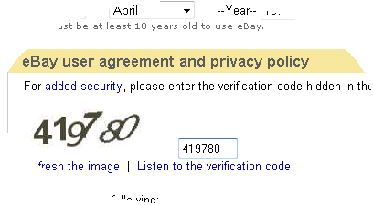

Read the user agreement and tick the box to say that you agree to the terms.
Click continue....if all of your details are correct then you will receive a notification to check your email for a confirmation code.
Go to your email and find the email from ebay, click on the link in the email and enter the confirmation code for your account.
That's it all set up and ready to go on ebay!

Fairly soon you will receive a welcome email from ebay.

Now for an Amazon account:
Go to www.amazon.co.uk


Click on where it says “New Customer? Start here”

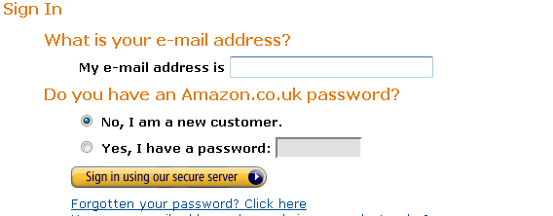
Enter your email address and select the No, I am a new customer. Then click the sign in button.

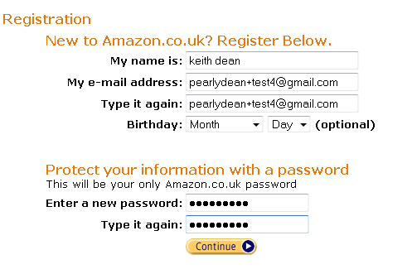
Now fill in your details as I have done....your details though not mine doh!
Click on the continue button.
You will be taken to a new page, scroll to the bottom and click on Sell on Amazon

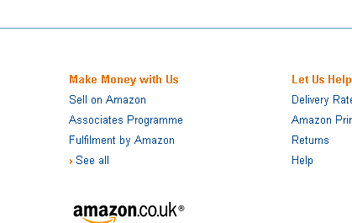

You now have a choice to sell a little or sell a lot. At this stage unless you plan to sell more than 50 or so CD's or DVD's choose the sell a little option as you can always sign up to the other option once you have got established.

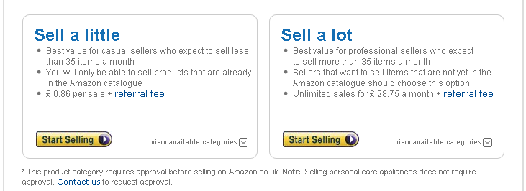
As you can see here it will cost you £0.86 per sale plus a referral fee for this option. When you are selling more then you won't have to pay the £0.86 fee per item but instead pay a monthly fee of £28.75 a month. For example if you sell 100 items in a month it would cost you £86 with the first option but only £28.75 with the second option.
Click on the Start Selling button and you will see this page...

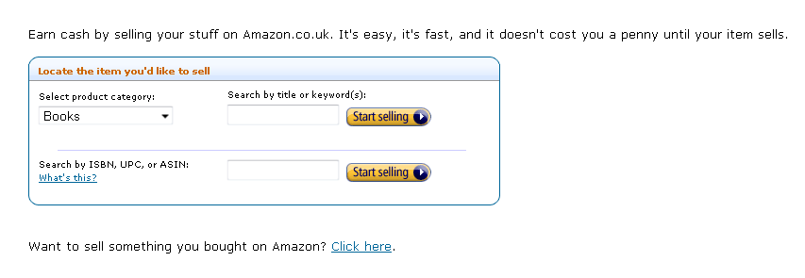
So there you go, you are now set to buy and sell on either ebay or amazon.
Exciting stuff as this is the real start of your business.

SELL YOUR OWN CD'S FIRST

OK so this is the way to get started quickly and easily especially if you don't have any money to buy CD's from somewhere else. This is what I did to get started myself...
One of the reasons that I have built a successful on-line income is my positive outlook, professional approach and can-do attitude, which I believe is integral to my success. Also if you are not prepared to do a bit of hard work in building your business then stop now and do something else!
After my other business stopped I was at a bit of a loose end and was researching all types of business opportunities and careers.
I came across all the usual get rich quick rubbish that you have probably already seen yourself.
In the meantime my wife and I wanted an MP3 player each, as we are both big music fans and wanted to have our personal collections in a more mobile format.
We had a look on the Internet and priced up two 40 GB Apple iPods. They were £278 each at the time. The only trouble is we didn't have a spare £556 to buy them.

I joked that we could try selling the CD's that we didn't want, to pay for them, keeping the music on our computer ready for when our iPod’s arrived.
We had no idea whether this would work but gave it a try. The first day I sold 6 CD's and made around £30 – still £526 to go!
I looked into how other people were selling CD's to work out how to sell more and make more profit. It took me around 8 months to perfect this, and I am still learning and increasing my income every single day.
To cut a long story short we sold enough CD's in 2 months to pay for two iPods, and have money left over. The realisation that this could actually be a viable business was quite exciting!

The thing to do now then is to go and have a look at your collection and see what you want to sell and what you want to keep. Then get them listed on ebay or amazon.

HOW TO LIST YOUR CD'S OR DVDS

So hopefully you have a nice pile of CD's ready to list now. The first thing to do is to grade them using the standard grading terms – I have taken this from Amazon as I want you to start listing there first.

Collectable music
Must be signed, out of print or otherwise unique--you will have an opportunity to say why your copy is collectable. We suggest that you list such music at a price greater than the Amazon.co.uk price.

New music
A brand-new, unused, unopened CD or cassette in perfect condition.

Used music
- Like New: an apparently unopened CD or cassette in perfect condition (although it may be out of its original wrapping). The jewel case or cassette case has no scratch or scuffing. The inlay notes, inclusions and/or sleeve are in perfect condition. The CD or tape itself is unmarked with no sign of wear. CD or cassette may have a remainder cut-out on the spine but this should be noted in listing comments.
- Very Good: a well-cared-for CD or cassette that has been listened to but remains in great condition and plays perfectly. The jewel case or cassette case may show limited signs of wear, as may the inlay notes and inclusions.
- Good: the CD or cassette plays perfectly but has clear signs of wear. This jewel case or cassette case is undamaged, and original liner notes are in good, unmarked condition.
- Acceptable: the CD or cassette plays perfectly, but is otherwise the worse for wear. The jewel case or cassette case may be damaged, and the inlay notes may be marked (but remain complete and legible). The CD or cassette or packaging may have identification markings from its owner.
Once you have signed into Amazon with your username and password you need to click on the Your Account link at the top right hand side of the page:

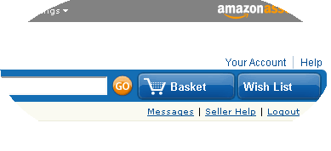

Now you need to click on the link Sell Your Stuff on the right hand side further down:

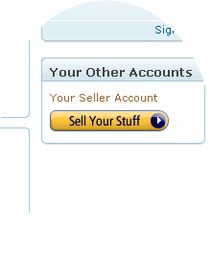
You will now be in the page where you can List single items and this is the tab you need to click:

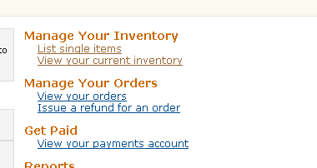
Nearly there now so bear with me! When you have clicked this link you will be at this page:

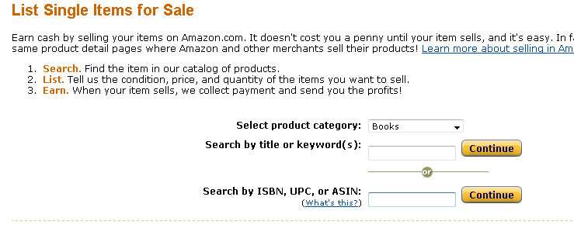
You can select the product category – so if it's a CD or DVD then choose that. You can then either search for your product by title or keyword or if you have a barcode on the back of the CD or DVD put that into where it says Search by ISBN, UPC, or ASIN.

I have selected Popular music and put in the barcode like so:

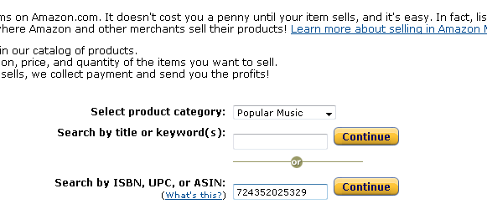
Click on continue:

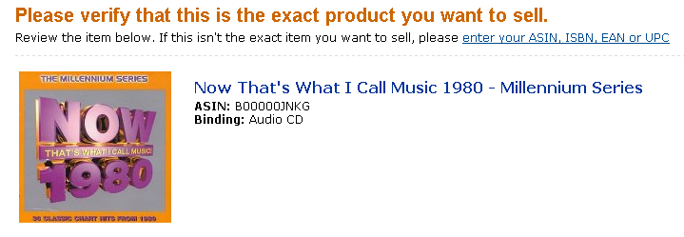
This is the product I want to sell so now I need to select the condition of the item:

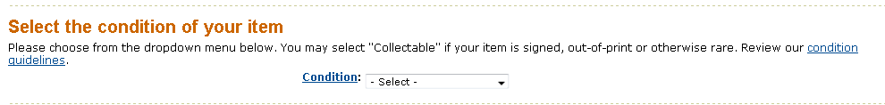
Click on the drop down box to select the condition – you will see the different options and refer to the gradings chart earlier in this guide.

My copy of this CD is in excellent condition so I will select Used – Very Good as it isn't in Mint or New condition and it is extremely important that you list as honestly and accurately as possible.

If you look at the next box it is where you will put the description of the item:

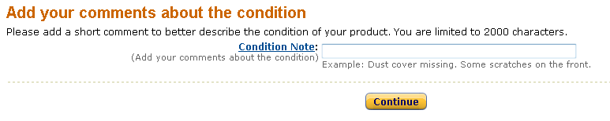
So go ahead and add your description and click on Continue...

Now you need to enter a price for your product:

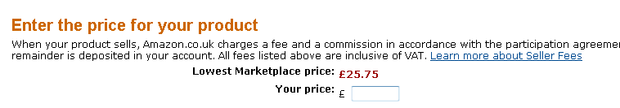
As you can see the Lowest Marketplace price is £25.75 and if you want a quick sale then by all means put it in a penny cheaper at £25.74. However, I know my market and as long as my copy is in comparable condition I will wait a little longer and price it higher at £29.99. From past experience I know this will sell at this price in a week or two and I will have made extra profit!

Now put in the quantity that you are selling so in this case 1, and decide whether you will sell in your country only or Internationally. I always sell Internationally as I get quite a few extra sales from this.

Click continue and you should see this page:

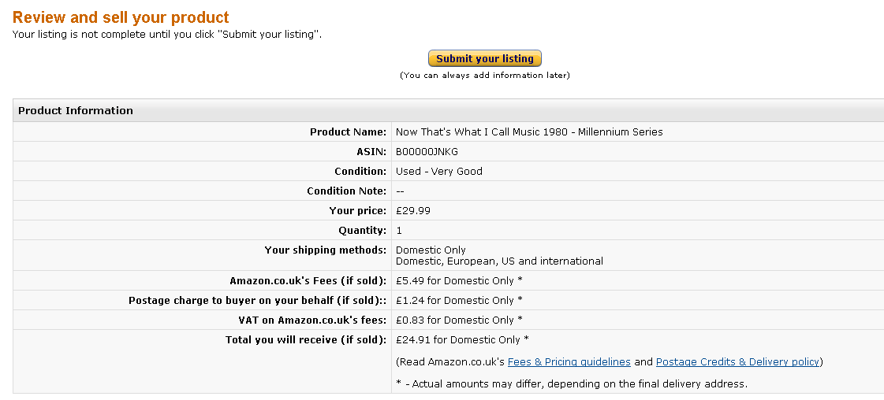
You will see that you get different postage credits for different countries and then Amazon takes its commission so you have left the price if sold – in this case £24.91. You need to post the item (that's what the postage credit is for) so those costs need to be accounted for but as I bought this CD for £2.78 I have still made a healthy profit.

Now click on submit your listing and it has been added to Amazon!

This is a screenshot of the inventory of this item:

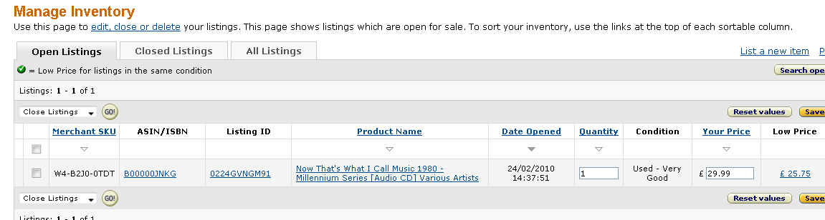
As you add new products you will see them in the inventory and you have the ability here to change quantities or prices or delete if sold elsewhere. As the items are sold Amazon automatically adjusts the inventory so you don't need to do that for each sale!

So if you are selling your own CD's and DVD's then do this for each one until they are all listed. The more inventory you have the more sales you will get and you will be building up profits ready to buy the more collectable items later on – that's when you will make much bigger profits.

PRICING TIPS AND FEEDBACK

Don’t always go for the lowest price! When I first started I always put the lowest price believing that people would only buy the cheapest. What actually happens is that they choose first from the condition – so a “Very Good” copy will sell before a “Good” copy.
Then they look at the description – I always describe the CD accurately as it helps with feedback later. For example “Good condition – surface scratches but plays perfectly”.
Then they look at the price. So you could have a “Very Good” copy and the cheapest on Amazon used is an “Acceptable” copy selling for 99p. The next one above that is a “Very Good” copy which is on sale for £2.99. I would put mine on at £3.49 but as you are just starting out I would suggest either £2.98 or £2.99.
The reason I can sell for £3.49 is my feedback. Currently I have 9873 ratings with a feedback score of 100% - people trust that I provide a good service so will pay that little bit extra. Here are some examples of feedback I have received:

5 out of 5: | "Very good seller. Item dispatched quickly"  Date: 2009/5/12 Rated by Buyer: Tony Parker
5 out of 5: | "The CD was delivered in time in an exelent way. I am very satisfied with this seller."  Date: 2009/5/11 Rated by Buyer: Tom Arne Moe
5 out of 5: | "Beautiful CD - So calming and Sent Fast and Secure. Very Well Packed and would definitely recommend this Seller! BUY WITH CONFIDENCE! Thank you."  Date: 2009/11/11 Rated by Buyer: L TRaynshaw
5 out of 5: | "no problems with the service so will use this site again."  Date: 2009/11/10 Rated by Buyer: Hilary
4 out of 5: | "Good Item and good price - smooth transaction - would recommend!"  Date: 2009/11/10 Rated by Buyer: Joely Smanatha Fray
5 out of 5: | "Very speedy just what we needed. Most impressive!"  Date: 2009/11/10 Rated by Buyer: Mrs Abigail Duignan
5 out of 5: | "arrived on time. good condition. cheers"  Date: 2009/11/10 Rated by Buyer: Miss Laura Connelly
5 out of 5: | "Excellent communication, excellent transaction, a pleasure to do business. A++++"  Date: 2009/11/10 Rated by Buyer: Lynda Eld)
5 out of 5: | "Arrived extremely quickly excellent condition will use again"  Date: 2009/11/10 Rated by Buyer: TINA BEAUMONT)

CUSTOMER SERVICE
As you can see great customer service gets you great feedback!

This is the foundation of my business and I need you to understand how important this is to you when you get started. For example you have probably bought this ebook from me on ebay. I currently have 100% feedback on ebay and Amazon - this gives people the confidence to buy from me. My excellent reputation creates even more sales and also you can charge that little bit extra as people perceive (correctly) that they are getting value for money.

I always provide a full refund if there is a problem with a CD or DVD. I always think about how I would feel if I received a bad service or product. If in the past this has happened to me then I expect the seller to put it right or give me my money back.

I have had customers who have had a refund from me who then leave a positive feedback as they are impressed with the customer service.

POST OFFICE CLAIMS

The occasional item gets lost in the post and once again I always provide a replacement or full refund if this happens. I then claim it back from the post office so the customer is happy and I don't lose out. The main thing is that you are providing excellent customer service and gaining valuable positive feedbacks which ensure that you make more sales.

EFFICIENT BUSINESS MANAGEMENT

When I first started this business I was all over the place! I had CD's and DVD's coming out of my ears...I tried filing them in alphabetical order – but had to keep rearranging them. I now have some great tips for you which will save you a lot of time and effort and I hope you will thank me for it as you progress with your business:

STOCK CONTROL
I purchase cardboard boxes that are approximately 6 x 4 x 4. They hold around 20 -23 CD's and fit into my bookcases nicely. Each box is then numbered with a SKU (Stock Keeping Unit) and filed in order. When I list my CD's on Amazon I put in the SKU number and then file it away in the relevant box. I keep a spreadsheet of my SKU's with a page for each SKU. This makes it easier to keep control of the stock and also when I make a sale I can then delete this item from the stock so I also know what my stock levels are and how much value I have in stock.

ACCOUNTING
I also have an accounting spreadsheet which is invaluable to the business. It shows me what I paid for an item, what it sold for, what the gross profit is, what the net profit is and all sorts of other useful information.

RETURNS
If I have a returned item I first of all check that it is damaged.
You do get the odd customer who obviously buys the CD and then copies it before asking for a refund. This doesn't happen often but keep a look out as you don't want to discard a perfectly good CD that can be resold.
I also check whether I can repair the CD. I have recently bought an excellent CD repair machine from Hong Kong and it repairs anything but the worst scratches.

TIME MANAGEMENT
This is a hard one for me. It is so easy to get distracted from the priority tasks that need doing! I used to go off doing all sorts of things and then realised that the most important jobs were not getting done in time.
I won't try to lecture you on Time Management too much as you may already be an expert. If you are then skip this bit!

I use the Franklin Covey method as follows:
Each morning I write down the things I need to get done plus the things I would like to get done. For example:

Print off yesterday’s sales
Put the sales sheets in SKU order
List any new stock
File new stock away
Update accounting spreadsheet
Stocktaking
Cashflow
Find sales ready for packing
Check all CD's and cases
Clean or repair any CD's that require it
Take sales to the post office

and so on...

I then put the tasks into A, B and C priority...

Print off yesterdays sales A
Put the sales sheets in SKU order A
List any new stock B
File new stock away B
Update accounting spreadsheet C
Stocktaking C
Cashflow C
Find sales ready for packing A
Check all CD's and cases A
Clean or repair any CD's that require it A
Take sales to the post office B

Then I prioritise within each category for example A1, A2, A3 etc as follows:

Print off yesterdays sales A1
Put the sales sheets in SKU order A2
List any new stock B1
File new stock away B2
Update accounting spreadsheet C2
Stocktaking C3
Cashflow C1
Find sales ready for packing A3
Check all CD's and cases A4
Clean or repair any CD's that require it A5
Take sales to the post office B3

So now I have a working plan for the day and the most important tasks get done first!

POSTAGE AND PACKING
You need postage and packing to be as cost effective as possible. I find that buying padded envelopes in bulk from Staples or Viking can save me a lot of money on buying then elsewhere. I order about 300 at a time and they only cost me 12p per envelope. If you go into a Staples store and buy them they are 25p each!

I have also bought spare CD cases in bulk from Ebay The price depends on the amount you buy, but it means that you can buy CDs very cheaply if they are in cracked cases, and as long as the CD and insert are in good condition, replacing the case will make them look almost as good as new for resale.

It means that your buyers will feel they are getting very good value for money and leave you good feedback which as I have already explained can increase your profit by over 100%.
I usually pay around 10p per CD case when I order 100 or more at a time. Just factor this cost into your selling price.
One of the first things I bought myself was a Selotape dispenser, as, if you are successful you’re going to be packing a lot of CDs each day, and the less time consuming this is the better.
You will need a decent printer as well, with cheap cartridges. If you don’t already have a printer, I’d recommend spending a little more on a printer that then has very cheap ink refill cartridges. You’ll find you save a lot in the long run.
My printer is a Brother MFC 3820CN and my replacement cartridges only cost £3.00 each from the internet (I buy mine from www.choicestationery.com). One of my earlier printers cost £24.99 for new cartridges which really cuts into your profit.
You may also want to consider investing in getting some stickers made with your name and address on them and putting them on the packing slip. They aren’t very expensive, but just give a touch of professionalism to the end result that your customer will receive.

Please note – if you are going to do this, then don’t stick one of your address labels to the outside of the packaging. Mine identified me as a CD and Book Seller, and I found that a regular proportion of my CDs were going missing in the post. When I started to put the sticker on the packaging slip on the inside of the envelope this stopped. You can draw your own conclusions!

SELLING WORLDWIDE

This is a tip for when you have got yourself established on Amazon and are seeing some sales. I started off just selling to the UK market and then realised that by listing worldwide some of my more collectable CD's were being snapped up by collectors abroad who couldn't find them in their own country.
The postage credit is better and it is just the same process as selling to the UK. When you take your sales to the post office make sure any overseas sales have an airmail sticker on them and also write “SMALL PACKET” on the envelope to take advantage of this cheaper rate.
Also if the customer is from a non EU country then you also need to put a customs sticker on the back of the envelope. Just ask at the post office if you are not sure about this and they are always pleased to help. I have a great relationship with my local post office now as they see me every day and appreciate the business I put their way!

RESEARCH PRICES AND MOVERS

Once you have built up some money from your own sales you need to start looking for new stock. I always research prices and make a spreadsheet of items I am interested in. I then go back at least once a month to update the prices to keep on top of the game.
I sell a very collectable CD set – Essential Mix by Pete Tong. At one stage I was able to buy this from ebay for anything between £1 and £5 and then sell it on Amazon for up to £30! However, more copies started coming into the marketplace which lowered the price unfortunately.
I will just have a check now to see what it is going for on Amazon:
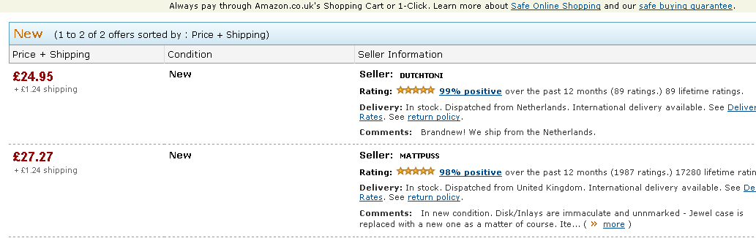

Yes it is still at a good price - £24.95 for a nearly new copy...now over to ebay for a look there- you can pick them up for round about £5 from here so good scope for profit.

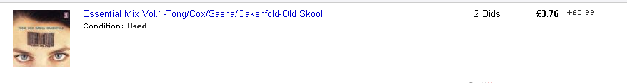

The price of this has gone up again on Amazon from around £9 to nearly £25 so you can see how prices fluctuate giving you scope for making profit if you follow the movements.

CONCLUSION

I hope this guide has helped you on your way to making some quick money. The thing to do now is take action and get some items listed and before you know it you will be well on your way.

